Apps & Programs Chart
= Apple Device | = Android Device | = Microsoft Device | = Chrome Browser | ✅ = Can access via all browsers | 👍 = Sign up for an account

Technology Tools |  |  |  |  | Can access via...
Icon | Name | Description | Cost | Sign up for an account | App Download | Computer Download | Web-  Based | Website
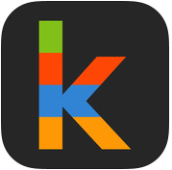 | Klikaklu | Klikaklu Player - Scavenger and Treasure Hunts is a photo hunt game that uses your phone's GPS, camera, and advanced image matching technology. It's a great way to quickly create and play treasure hunts and a great alternative to geocaching or QR Code scavenger hunts! | See website for pricing | 👍 |  | -- | -- | http://www.klikaklu.com/
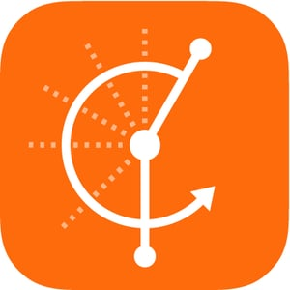 | Hudl Technique | Hudl Technique is a video analysis app available on iOS and android. | Free | 👍 |  | -- | -- | http://www.hudl.com/products/technique
 |  | Vidalyze is a game changing Video Analysis Tool designed exclusively for Schools. Vidalyze makes video analysis a realistic and scalable experience dealing with user management, video storage, teacher feedback and the assessment process. Never before has it been this easy to utilise the power of video within your classroom. It works 100% inside of your web browser meaning there is no complicated software to install and your students can use it on any device with an internet connection. | See website for pricing | 👍 | -- | -- | ✅ | https://www.vidalyze.com/
 |  | Kinovea is a video player for all sport enthusiasts. Slow down, study and comment the technique of your athletes or of yourself. It is 100% free and open source. | Free | -- | -- | ✅  (Cannot download to a Chromebook) | -- | http://www.kinovea.org/
 | LIVE Video Delay | LIVE Video Delay allows you to monitor live video on an adjustable delay of up to 10 minutes. Your students can get immediate feedback during your lessons and make your class more productive. | $4.99 | -- |  | -- | -- | --
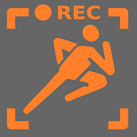 | Video Coach | Video Coach is a simple yet powerful real-time video analysis tool. Video coach helps you analyse and improve your sporting activities or the performance of your students or athletes if you are physical education teacher or coach. | Free download, license fee after trial | -- |  | -- | -- | --
 | Replay It | Replay It - Sports Video Delay Tool is the world's first Video Delay application made exclusively for Google Chrome. A simple yet powerful real-time video analysis tool that helps you analyse and improve your sporting activities or the performance of your students or athletes. | Free | -- | -- | -- | (Chrome Extension) | Access via the Chrome Web Store  https://chrome.google.com/webstore/category/extensions
 | Plickers | Plickers is an app you can download to iOS and Android. You use your device to scan, but set up everything via computer. | Free | 👍 |  | -- | ✅ | https://plickers.com
 | I-Nigma | I-Nigma is a QR Code Scanner app is fast and saves history. | Free | -- |  | -- | -- | http://www.i-nigma.com/downloadi-nigmareader.html
 | Anatomy 4D | Anatomy 4D transports students, teachers, medical professionals, and anyone who wants to learn about the body into an interactive 4D experience of human anatomy. | Free | -- |  | -- | -- | http://anatomy4d.daqri.com/
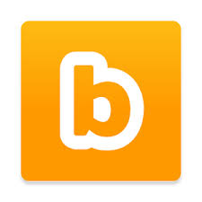 | Blippar | Blippar uses the most advanced mobile Augmented Reality. Blipp objects you're curious about and unlock useful and entertaining content. | Free | 👍 |  | -- | ✅  (You create your blipps in the lab via your browser) | https://blippar.com/en/learn-more/blippar-for-education/
 | Airserver | AirServer is the most advanced screen mirroring software receiver for Mac, PC and Xbox One. It allows you to receive AirPlay, Google Cast and Miracast streams, similar to an Apple TV or a Chromecast device. | $11.99 for educators | -- | -- | ✅ | -- | https://www.airserver.com/
 | Mirroring360 | Mirroring360 lets you wirelessly share & record your Chromebook, iPad, iPhone, Android*, Windows, and Mac screens without the need for hardware or cables. Start sharing your work, your ideas, and your latest apps with Mirroring360. | $14.99 | -- | (Apple devices does not need an app) | ✅ | (If using a Chromebook you will want to install a Chrome Extension) | http://www.mirroring360.com/
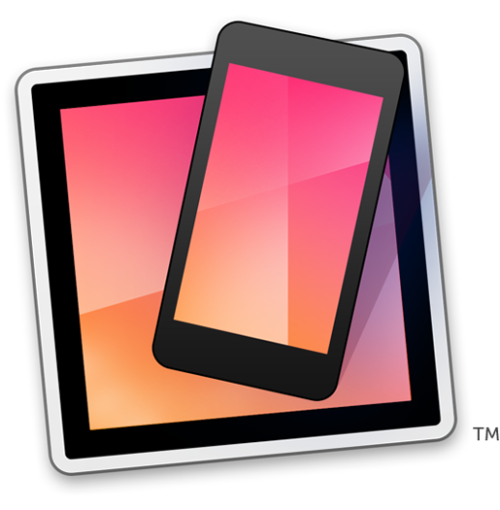 | Reflector 2 | Reflector 2 lets students take a hands-on approach to their education. Reflector is a budget friendly, easy-to-use solution that makes sharing ideas and engaging students effortless. Untether from the desk or podium, and display your Chromebook, iOS™ or Android™ screens wirelessly from anywhere in the classroom. Reflector is helping to revolutionize the interactive classroom. | $14.99 | -- | (Can access Reflector Director and Reflector student via iOS) | ✅ | -- | http://www.airsquirrels.com/reflector/
 | FIT Radio | Spend time sweating, not making playlists with the App Store's No. 1 workout music app, Fit Radio, featuring new professional DJ mixes every day. It also includes an interval timer. | Free download, subscription pricing | 👍 |  | -- | ✅ | http://www.fitradio.com/
 | Tempo Magic | Tempo Magic changes the BPM of your music! It lets you speed up or slow down the BPM (Beats Per Minute) of any song on your device without messing with the pitch. It won't ruin your favorite songs with high-pitched chipmunk lyrics or slowed down zombie vocals.Tempo Magic adjusts the music straight from your app - no lengthy uploads or importing required. Just pick your playlist and go. | $5.99 on iOS, $4.99 on Android | -- |  | -- | -- | https://www.yesfitnessmusic.com/magic
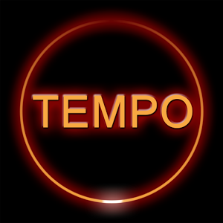 | Tempo SlowMo | Tempo SlowMo allows you to changes the BPM of your music! It lets you speed up or slow down the BPM (Beats Per Minute) of any song on your device without messing with the pitch. It also allows you to import tracks from music library sync’d to device, change tempo while playing between 20% and 250% or original tempo, and more! | Free | -- |  | -- | -- | http://www.chord-detector.com/wordpress/apps/tempo-slowmo/
 | Yes!GO | Yes!GO flawlessly incorporates Tempo Magic Pro Pitching technologies and allows you to changes the BPM of your music! It lets you speed up or slow down the BPM (Beats Per Minute) of any song on your device without messing with the pitch. This app has custom pre-mixed songs for you to access for free from the device. | Free, can also pay for subscription to add more features | -- |  | -- | -- | http://www.yesfitnessmusic.com/store/product_detail/YESGO-ALL
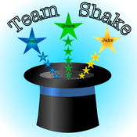 | Team Shake | Team Shake is a grouping app that is totally worth spending the $0.99! | $0.99 | 👍 |  | -- | -- | http://www.rhine-o.com/iphone-apps/team-shake /

 | Lazy Monster | If you are tired of boring workout apps, then you should check out 7 minute workout with Lazy Monster. This fun and upbeat fitness app has a cute, orange, one-eyed monster who can do 10 different exercises without equipment or machines. | Free | 👍 |  | -- | -- | https://appadvice.com/appnn/2015/04/7-minute-workout-with-lazy-monster-is-a-fun-fitness-app

 | Sworkit KIds | Exciting workouts for kids that can be done anywhere in as little as 5 minutes! Available for iOS and Android. Check out our apps for the entire family. | Free |  |  | -- | -- | http://kids.sworkit.com/

 | Tabata | Tabata Stopwatch Pro is the ultimate Tabata Interval Timer that works for 'all' your interval training needs. Use with Tabata, HIIT, kettlebells, bodyweight exercises, interval running, sprints, etc. | Free – cost for full version | 👍 |  | -- | -- | https://itunes.apple.com/us/app/tabata-stopwatch-pro-tabata-timer-and-hiit-timer/id664563975?mt=8

