Name of team: __________________________________________________
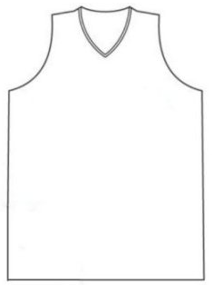
Club logo: Club jumper:

Location in Australia: _____________________________________________________

Last premiership: __________________________________________________________

Place on the ladder this year: ______________________________________________

3 players from the team:
- _______________________________________________________________________

- _______________________________________________________________________

- _______________________________________________________________________

