**[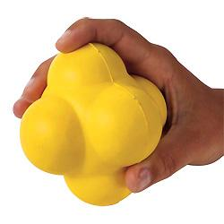](http://www.flaghouse.com/viewlarger.asp?itemno=14435)**

**John L. Smith**

**1989 NASPE/SHAPE National Teacher of the Year**

**[](http://www.flaghouse.com/viewlarger.asp?itemno=14435)Activities with Small Foam Reaction Balls**

**Small Foam Reaction Ball #14435**

**Individual**

* **Toss and Catch**
* **Toss Bounce and Catch (increase # of bounces)**
* **Toss with spin back and catch**
* **Toss, Bounce and Trap**
* **Toss 1 ball let it bounce, toss second ball while #1 is in the air, let it bounce and catch**
* **Toss 2 Balls and catch both after 1 bounce**

**Partners**

* **Roll and Scoop**
* **2 balls one with each partner, roll and scoop**
* **Bounce and Catch**
* **Pass back and forth one bounce**
* **Roll 2 balls at same time to partner, scoop and catch**
* **Roll 4 balls (each partner 2 balls) at same time, 2 center, 2 wide,**

**Group**

* **Toss in center of group, let it bounce and catch**
* **Toss in center of group, let if bounce, catch, repeat with one more bounce added on each successful catch**

**Sport Skills: Baseball and Softball**

**Bounce into Buckets**

**Roll into hoop**

**Off the wall skills:**

* **To self**
* **To partner**
* **Change distances**
* **Increase # of bounces**
* **One ball each partner to other partner off the wall**

**John L. Smith**

**Educational Consultant**

**FlagHouse Inc.**

**201-329-7528 – O**

**201-788-6283 - Cell**