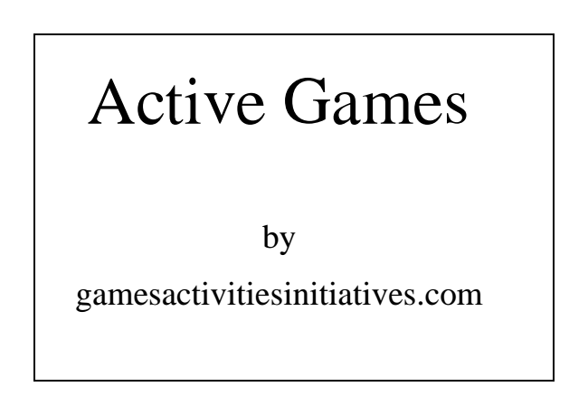
Active Games
by
gamesactivitiesinitiatives.com
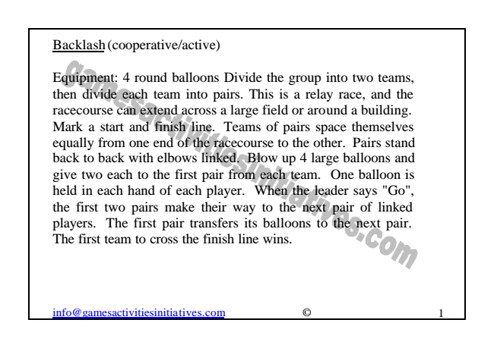
Backlash (cooperative/active)
Equipment: 4 round balloons Divide the group into two teams, then divide each team into pairs. This is a relay race, and the racecourse can extend across a large field or around a building. Mark a start and finish line. Teams of pairs space themselves equally from one end of the racecourse to the other. Pairs stand back to back with elbows linked. Blow up 4 large balloons and give two each to the first pair from each team. One balloon is held in each hand of each player. When the leader says "Go", the first two pairs make their way to the next pair of linked players. The first pair transfers its balloons to the next pair. The first team to cross the finish line wins.
info@gamesactivitiesinitiatives.com © 1
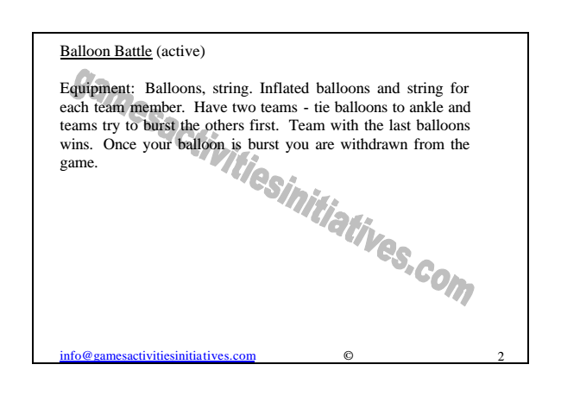
Balloon Battle (active)
Equipment: Balloons, string. Inflated balloons and string for each team member. Have two teams - tie balloons to ankle and teams try to burst the others first. Team with the last balloons wins. Once your balloon is burst you are withdrawn from the game.
info@gamesactivitiesinitiatives.com © 2
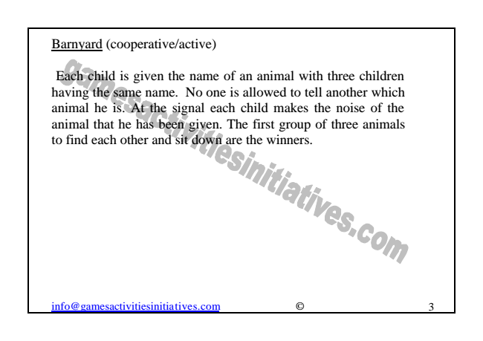
Barnyard (cooperative/active)
Each child is given the name of an animal with three children having the same name. No one is allowed to tell another which animal he is. At the signal each child makes the noise of the animal that he has been given. The first group of three animals to find each other and sit down are the winners.
info@gamesactivitiesinitiatives.com © 3
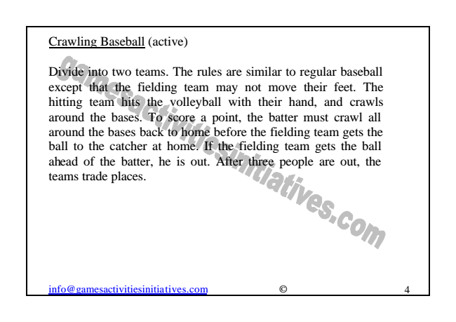
Crawling Baseball (active)
Divide into two teams. The rules are similar to regular baseball except that the fielding team may not move their feet. The hitting team hits the volleyball with their hand, and crawls around the bases. To score a point, the batter must crawl all around the bases back to home before the fielding team gets the ball to the catcher at home. If the fielding team gets the ball ahead of the batter, he is out. After three people are out, the teams trade places.
info@gamesactivitiesinitiatives.com © 4
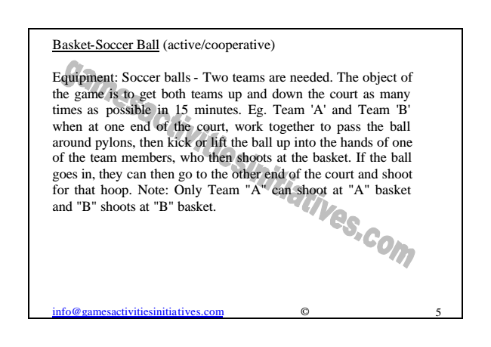
Basket-Soccer Ball (active/cooperative)
Equipment: Soccer balls - Two teams are needed. The object of the game is to get both teams up and down the court as many times as possible in 15 minutes. Eg. Team 'A' and Team 'B' when at one end of the court, work together to pass the ball around pylons, then kick or lift the ball up into the hands of one of the team members, who then shoots at the basket. If the ball goes in, they can then go to the other end of the court and shoot for that hoop. Note: Only Team "A" can shoot at "A" basket and "B" shoots at "B" basket.
info@gamesactivitiesinitiatives.com © 5
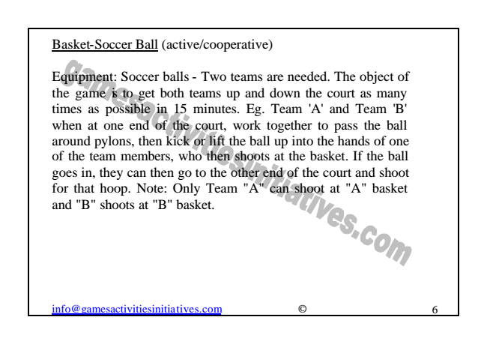
Basket-Soccer Ball (active/cooperative)
Equipment: Soccer balls - Two teams are needed. The object of the game is to get both teams up and down the court as many times as possible in 15 minutes. Eg. Team 'A' and Team 'B' when at one end of the court, work together to pass the ball around pylons, then kick or lift the ball up into the hands of one of the team members, who then shoots at the basket. If the ball goes in, they can then go to the other end of the court and shoot for that hoop. Note: Only Team "A" can shoot at "A" basket and "B" shoots at "B" basket.
info@gamesactivitiesinitiatives.com © 6
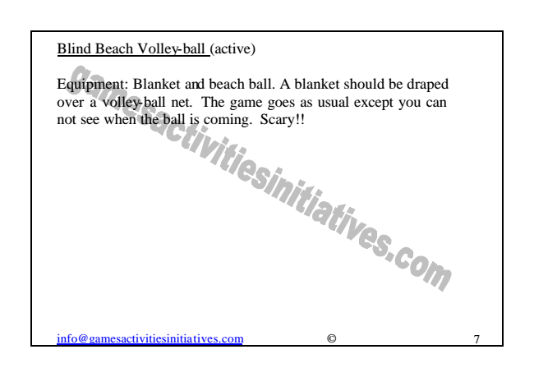
Blind Beach Volley-ball (active)
Equipment: Blanket and beach ball. A blanket should be draped over a volley-ball net. The game goes as usual except you can not see when the ball is coming. Scary!!
info@gamesactivitiesinitiatives.com © 7
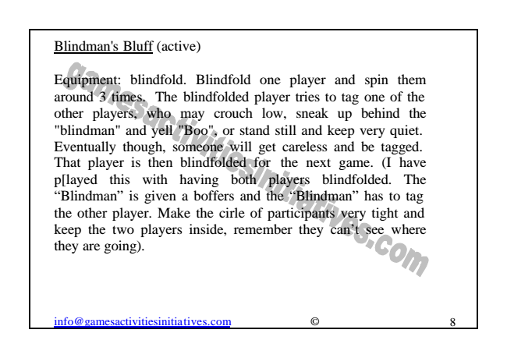
Blindman's Bluff (active)
Equipment: blindfold. Blindfold one player and spin them around 3 times. The blindfolded player tries to tag one of the other players, who may crouch low, sneak up behind the "blindman" and yell "Boo", or stand still and keep very quiet. Eventually though, someone will get careless and be tagged. That player is then blindfolded for the next game. (I have p[layed this with having both players blindfolded. The “Blindman” is given a boffers and the “Blindman” has to tag the other player. Make the cirle of participants very tight and keep the two players inside, remember they can’t see where they are going).
info@gamesactivitiesinitiatives.com © 8
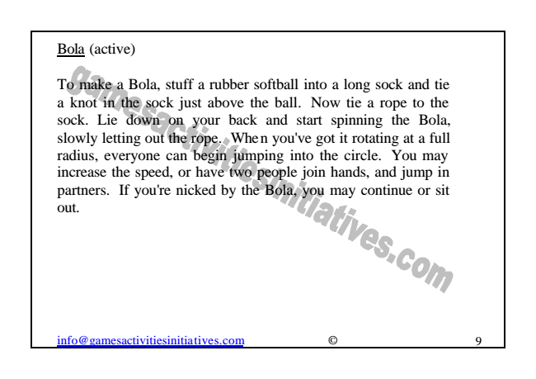
Bola (active)
To make a Bola, stuff a rubber softball into a long sock and tie a knot in the sock just above the ball. Now tie a rope to the sock. Lie down on your back and start spinning the Bola, slowly letting out the rope. When you've got it rotating at a full radius, everyone can begin jumping into the circle. You may increase the speed, or have two people join hands, and jump in partners. If you're nicked by the Bola, you may continue or sit out.
info@gamesactivitiesinitiatives.com © 9

