Y10 BTEC PE REVISION PACK
Name:

SKILL components of fitness | Definition | Who would need it? Give a specific example.
Power | Is a combination of __________________ and  _________________
Coordination | The ability to…  The three types of coordination are:
Reaction time | The time taken to…
Agility | The ability to...
Balance | The ability to…  The two types of balance are:

SKILL COMPONENTS OF FITNESS (POWER- CRAB)

PHYSICAL components of fitness | Definition | Who would need it? Give a specific example.
Aerobic endurance | The ability to…
Body composition | The ratio of… | A person who would need a large fat mass is:  A person who would need a low fat mass is:
Muscular endurance | The ability to…
Muscular strength | Applying maximum…
Flexibility | The ability to have a…
Speed | The ability to cover a…
Physical components of fitness (A Big Man Must Fill Shoes)
Fitness test | Component of fitness tested | Description / how to set up / equipment needed | Advantage/Disadvantage
The multi stage fitness test (Bleep test) |  | Equipment needed: cones, tape measure, audio equipment | Advantage:  Disadvantage:
The forestry step test |  | Equipment needed: steps, audio equipment | Advantage:  Disadvantage:
The one minute sit up test / press up test |  | Equipment needed: stopwatch, mat, assistant | Advantage:  Disadvantage:
The hand grip dynamometer test |  | Equipment needed: hand grip dynamometer | Advantage:  Disadvantage:
The sit and reach test |  | Equipment needed: sit and reach box, assistant | Advantage:  Disadvantage:
The 35m sprint test |  | Equipment needed: stopwatch, tape measure, cones, assistant | Advantage:  Disadvantage:
The vertical jump test |  | Equipment needed: vertical jump board, chalk, assistant | Advantage:  Disadvantage:
The illinois agility test |  | Equipment needed: cones, tape measure, stop watch, assistant | Advantage:  Disadvantage:
BMI  (Body Mass Index) |  | Equipment needed: scales, tape measure | Advantage:  Disadvantage:
Skinfold test |  | Equipment needed: skin fold callipers, assistant, pen for marking skin | Advantage:  Disadvantage:
BIA  (Bioelectrical Impedance Analysis) |  | Equipment needed: BIA analyser, alcohol wipes, electrodes, assistant | Advantage:  Disadvantage:
Fitness testing

20
19
18
17
16
15
14
13
12
11
10
9
8
7
6
MAXIMUM exertion (CANNOT DO ANYMORE)
Maximum heart rate
The safe maximum heart rate for an individual.
To work out maximum heart rate:
220 – age
E.g.
Harry is 26, his maximum heart rate would be 220 – 26 = 194 BPM

The Borg scale
Estimates how hard a person is working.
They would point at the scale to give their RPE.

RPE = Rating of Perceived Exertion

To estimate a persons heart rate using the Borg scale, multiply the RPE by 10.
E.g. Matt points to number 11 on the Borg scale whilst exercising, we can estimate his heart rate at that point to be 11 x 10 = 110 beats per minute.

HAVEA GO!
Molly is 17. Work out her aerobic training zone.

FITT Principles
F
I
T
T
Write down what each letter stands for and what it means.

No exertion (NOT HARD AT ALL)
To improve aerobic endurance, you need to get work with your heart rate in the aerobic training zone.
This is 60-85% of your maximum heart rate.
(Max HR / 100) X 60 = 60%
(Max HR / 100) X 85 = 85%

To improve your anaerobic endurance, you need to work with your heart rate in the anaerobic training zone.
This is 85-100% of your maximum heart rate.
(Max HR / 100) X 85 = 85%
Max HR = 100%

Additional Principle of Training | Definition | Example
S | This means you must keep the training…
P | This means to make training…
A | This means how the body…
R  + R | This means…
R | This means that fitness levels will be lost if…
I | Training must change depending on…
V | This means to change the type of training to…
Example: Anna is 25 with low fitness levels and wants to improve her aerobic fitness for an upcoming running race. In the example column explain how you would apply that principle of training.

Additional Principles of Training
Training method | Characteristics (describe it) | Who’s it good for? And why?
Circuit | A series of ____________ which…
Continuous | Training for at least _____ minutes. This improves your ____________  ________________ and can be done by…
Interval | A period of _________________________________________ followed by a period of _____________.
Fartlek | A type of _____________________ training that focuses on changing ________________ and  ______________.
Weight
Flexibility | Ballistic:  PNF:  Active/Passive:
Speed | Acceleration sprints:  Interval sprints:  Hollow sprints:
Plyometric | Involves muscles __________________ and _________________ quickly. Is mainly used  to improve…

Training methods
FLASH CARDS

What is AEROBIC ENDURANCE?  Give an example of a sports person who uses this component | What is MUSCULAR ENDURANCE?  Give an example of a sports person who uses this component
What is STRENGTH?  Give an example of a sports person who uses this component | What is SPEED?  Give an example of a sports person who uses this component
What is FLEXIBILITY?  Give an example of a sports person who uses this component | What is BODY COMPOSITION?  Give an example of a sports person who uses this component
What is AGILITY?  Give an example of a sports person who uses this component | What is REACTION TIME?  Give an example of a sports person who uses this component
What is COORDINATION?  Give an example of a sports person who uses this component | What is POWER?  Give an example of a sports person who uses this component
What is BALANCE?  Give an example of a sports person who uses this component | What are the 6 PHYSICAL components of fitness?  What are the 5 SKILL related components of fitness?

What component of fitness does Continuous  training improve? | What type of athlete would use Continuous  training?
What are the key characteristics of Continuous  training? | What is the advantages of Continuous  training?
What are the disadvantages of Continuous  training? | Give a specific sporting example of how an athlete would use  Continuous training?
What component of fitness does Fartlek  training improve? | What type of athlete would use Fartlek training?
What are the key characteristics of Fartlek  training? | What is the advantages of Fartlek  training?
What are the disadvantages of Fartlek  training? | Give a specific sporting example of how an athlete would use  Fartlek training?
Fill in the table to match the component of fitness to the fitness test and training method(s).
There may be more than one training method for each component.

Component of fitness | Sporting Example | Fitness Test | Training method
P
C |  | X | X
R |  | X | X
A |  |  | X
B |  | X | X
A
B
M
M
F
S

- Vertical jump test
- Multistage fitness test
- 1 minute sit up test
- Body Mass Index
- Forestry step test
- Sit and reach test
- 35m sprint test
- Illinois agility test
- Hand grip dynamometer
- Skinfold test
- Bio-electrical Impedance Analysis

- Continuous training
- Interval Training
- Fartlek training
- Weight training
- Circuit training
- Flexibility training (Active and passive, PNF, ballistic)
- Speed training (Hollow sprints, acceleration sprints, interval sprints)
- Plyometric training

BODY COMPOSITION
Definition -
Sporting Examples –
HIGH FAT LOW FAT HIGH MUSCLE
Skinfold Calliper Test
BIA
(Bioelectrical Impedance Analysis)

BMI
(Body Mass Index)
Definition -
Sporting Examples -
Multi-Stage Fitness Test
Forestry Step Test
AEROBIC ENDURANCE
Definition -
Sporting Examples -
1 minute Press up Test
1 minute Sit up Test
MUSCULAR ENDURANCE
Balance
Coordination
Definition –

Static Balance –

Dynamic Balance -
Sporting Examples -
Reaction time
Definition –

Sporting Examples -
Definition –

Sporting Examples -
Definition -
Sporting Examples -
Illinois Agility Run Test
Agility
Definition -
Sporting Examples -
Vertical Jump Test
Power
Picture
Picture
Definition -
Sporting Examples -
35m Sprint Test
SPEED
Definition -
Sporting Examples -
Grip Dynamometer Test
STRENGTH
Definition -
Sporting Examples -
FLEXIBILITY
Sit and Reach Test
Principles of training
Match the additional principle of training to its definition.
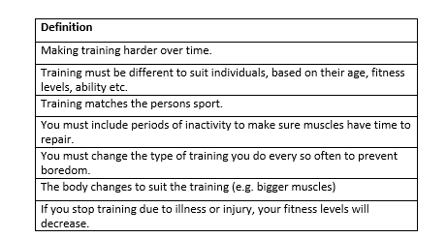
Additional principle of training
Specificity
Progressive Overload
Adaptation
Reversibility
Rest and Recovery
Individual needs
Variation

Exam questions:

1. Marie is a pole vaulter. She trains twice a week with her local athletics club. In her training she focuses on improving her power in her legs and hand grip strength. Discuss the specificity of her training activities. (2 marks)

2. Jordan is a boxer, he trains 3 times a week, 1 session of these is spent in the gym, he has been lifting 8kg for 3 weeks now. Explain how Jordan could improve his muscular strength. (2 marks)

3. If Jordan’s muscular strength improves, discuss how his body might show adaptation. (2 marks)

4. Marie got injured on 20th January whilst training. Discuss the effects of reversibility on her performance. (3 marks)

5. Explain why it is important Jordan includes rest days in his schedule when lifting heavy weights. (2 marks)

6. Explain 3 individual needs that are different for Jordan and Marie and explain how these affect their performance. (6 marks)

7. Explain how Marie could vary her training to reduce boredom. (2 marks)

8. Luke is a 1500m runner and wants to improve his aerobic endurance so that he can enter the 5000m race in July. Discuss how Luke should use the following additional principles of training in his training programme.
- Progressive overload
- Variation
- Rest and recovery.

PEE paragraph 1.
Progressive overload is…

I think Luke could use this by…

This would be good for Luke because…

PEE paragraph 2.
Variation is…
I think Luke could use this by…

This would be good for Luke because…

PEE paragraph 3.
Rest and recovery is…

I think Luke could use this by…

This would be good for Luke because

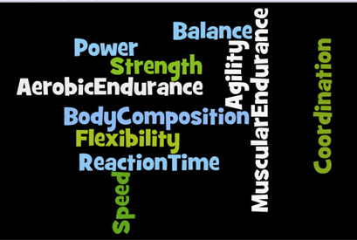
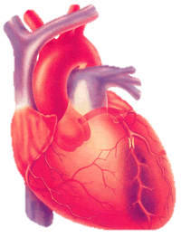
Components of Fitness
Skill - Related
C
B
A
P
R T
Principles Of Training
F………………. How ………………… you train,
I………………. How ………………….. you train.
T……………….. How …………………... you train.
T ………… What ……………..…you use to train.
What are the Additional Principles of Training?
RPE x …….
= …….
Max HR = ……… - age
A
M
M
F
S
B
All, Muscles, Move, Fast &, Slow, Bruv
Name this scale:
S.
PO.
R.
RR.
V.
IN.
A.
Fill me
in

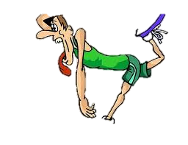
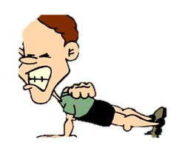
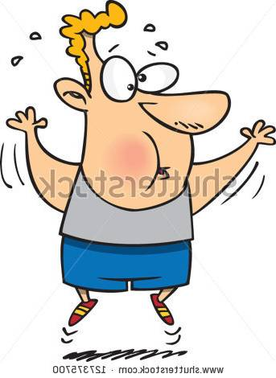
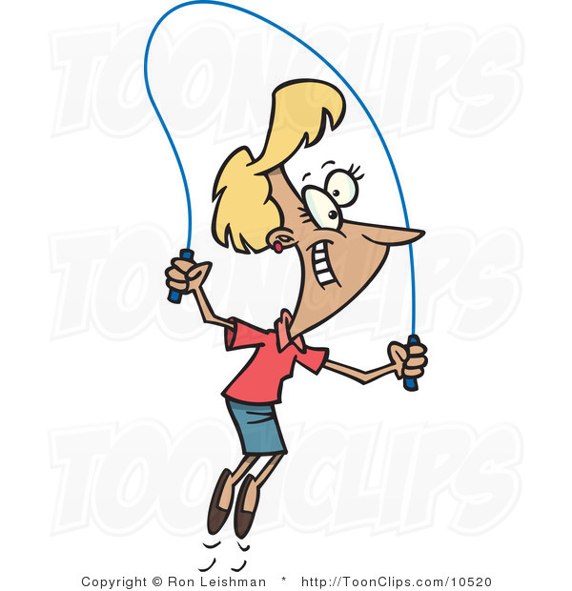
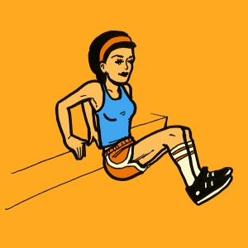
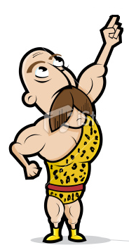
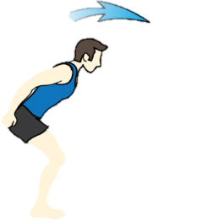
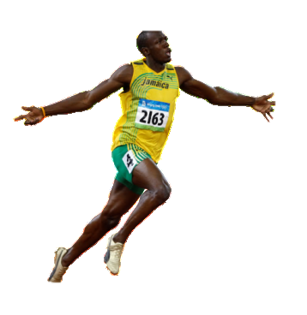
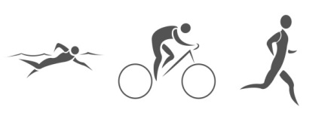

COF: ………………………………………..
- Continuous
- Fartlek ( ……….. play)
- Interval
COF: ……………………………
-
- (Bouncy)
- (Resistance)
Training Methods

Name each training method & state which component/s it trains.
COF: ……………………………
-
-
-
COF: ………………………………………
COF: ……………………………
List the Fitness Test used to test each Component of Fitness. (There may be more than 1 test per COF)
How can you use the FITT principles to provide Progressively Overload in a training programme?

When fitness testing we need to consider the Reliability, Practicality and Validity of the tests. What do these mean?

COF: ……………………………
Aerobic Endurance
Muscular Endurance
Flexibility
Speed
Body Composition
Strength
Agility

