BTEC NATIONAL

BTEC SPORT
Single + Double Course
Summer Homework Booklet 2020-21
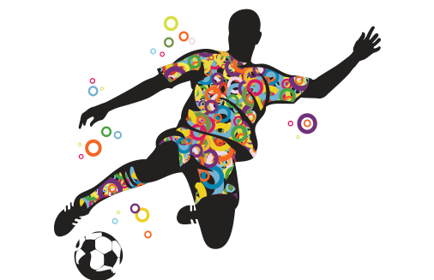

Name: ………………………………….

BTEC Sport - Summer homework
Thank you for downloading the BTEC Sport summer homework which you will need to bring with you in September. It is important that this is completed fully and you spend time on working through the booklet. Some parts should be familiar, other parts should challenge you but please make sure you have a go at everything.
Please feel free to contact Joe McTiffen – j.mctiffen@bhasvic.ac.uk if you have any problems with the work.
As mentioned in the introductory video, we will begin with anatomy which is an examined unit. Throughout the first part of the college year, you will be learning about the different systems and applying your knowledge to sporting examples.

PLEASE WATCH THE FOLLOWING 3 VIDEOS ON THE SKELETAL SYSTEM
A fantastic YouTube channel for you to subscribe to is
“Mike Tyler Anatomy & Physiology” some great videos for you to watch! Also follow him on Twitter @MikeTylerSport
https://www.youtube.com/watch?v=LMZStgTd-Tw&list=PLcdQDUUQX_4vcifsRu-iOyqZsxtlOsWxy&index=7
https://www.youtube.com/watch?v=mMecn9S4zW4&list=PLcdQDUUQX_4vcifsRu-iOyqZsxtlOsWxy&index=8
https://www.youtube.com/watch?v=ia8cG9LWa7M

Please watch one video at a time and complete the notes below. Once you have completed all of the notes for the videos, there is a little test for you to check your knowledge!

Major Bones – Use the 1st video for this section
Please complete the following diagram labelling all of the major bones in the skeletal system. Use the box below to tick off all of the major bones you have labelled on the diagram.
Cranium, clavicle, ribs, sternum, humerus, radius, ulna, scapula, ilium, pubis, ischium, carpals, metacarpals, phalanges, femur, patella, tibia, fibula, tarsals, metatarsals, vertebral column – cervical, thoracic, and lumbar vertebrae, sacrum, coccyx

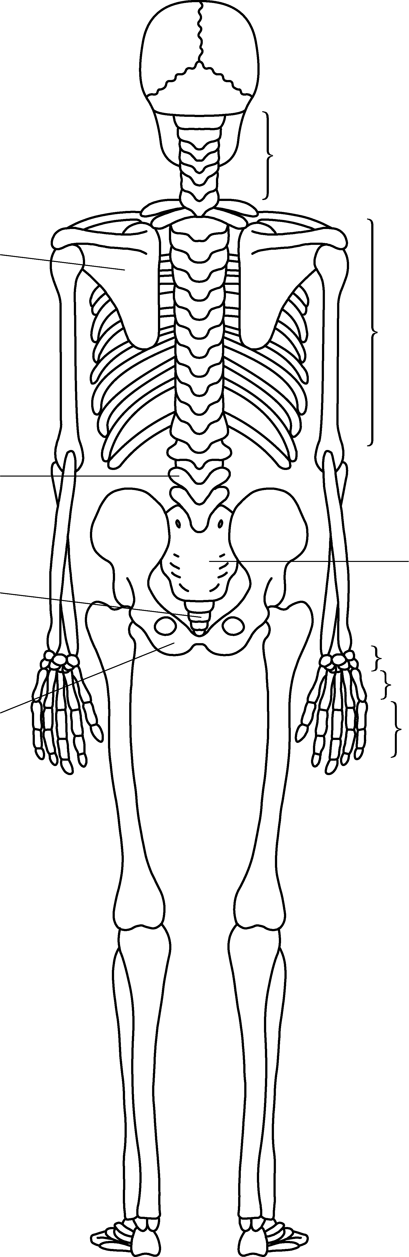
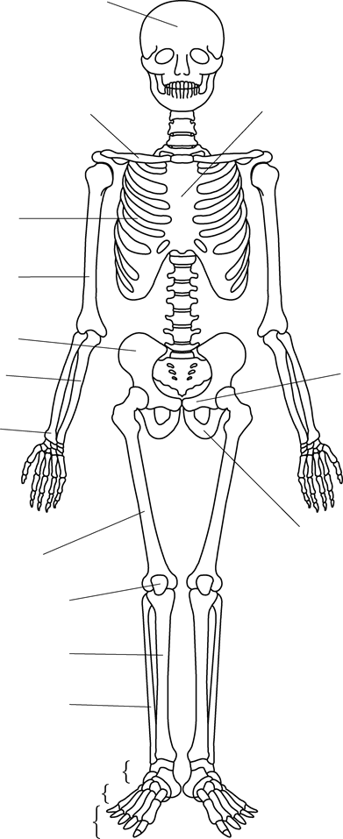

The human skeleton can be divided in to two parts – Axial and Appendicular skeleton. Looking at the diagram below, can you describe the main function of each skeleton?
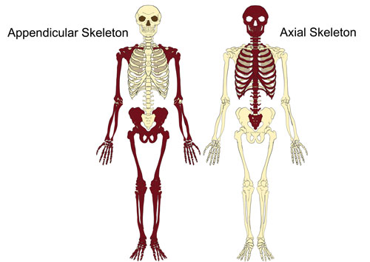
Appendicular Skeleton
Axial Skeleton
Postural Deviations
There are two common postural deviations that affect a number of people, can you explain all three? You will need to research scoliosis as it is not on the video.
Kyphosis Lordosis

Scoliosis (not on the video)

Bone Types and Functions – Use the 2nd video for this section
Type of bone | Function of the bone | Structure of the bone (how is the bone made up?) | Example of where the bone is found in the body

Using the knowledge from the table above, can you now apply this to a sporting example? An example has been given.
Type of bone | Function | What is it called and where is it found? | Sporting example
Long | Movement | Femur - Thigh bone | The femur is used for movement when an athlete is jumping over hurdles continuously moving their leg up and down.
Short

Irregular
Flat
Sesamoid
Long
Bone Remodelling – Use the 3rd video for this section!
Notes page – use this page to make notes and write down the key terms of the bone remodelling process. You should have notes on – ossification, osteoclasts, osteoblasts and osteoporosis. Draw some diagrams to help you!

Functions of the skeletal system
Using the table, explain each function of the skeletal system in detail.
Function | Explanation
Support and protection
Leverage and attachment
Weight bearing
Store of minerals
Blood cell production
Reduce friction at joints

Exam Questions
Once you have completed all of the notes above, make sure you read them through and have a go at the exam questions below. Please try and not use your notes to answer the questions, it doesn’t matter if you get them wrong, it is all
about learning!

Please make sure you have answered all the questions. This booklet should be fully completed when you come to college in September!

