-Describe the relationship between the heart, lungs, muscles, blood, and oxygen during physical activity.
-Describe and record the changes in heart rate before, during, and after physical activity.

Learning experience #1:

Part 1: Reading

Today, you are going to learn about something called cardiorespiratory endurance. Cardiorespiratory endurance if long word. However, we can break this word down into two parts. The first part of the word is “cardio.” The second part of the word is “respiratory.” What do you think these two words mean?
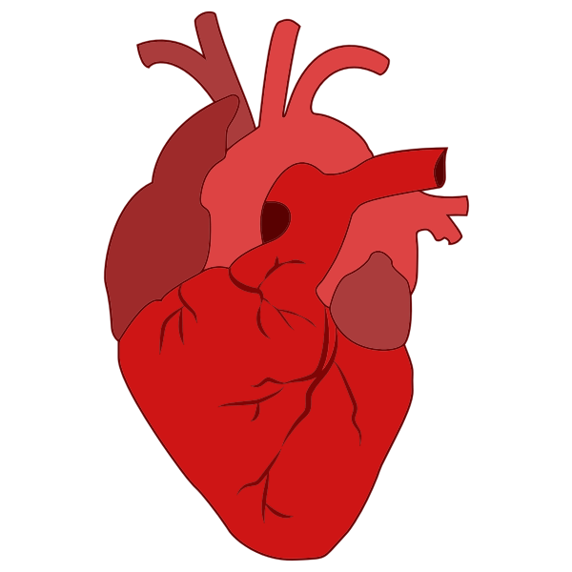
Cardio refers to the heart. Your heart is about the size of your fist.

Respiratory refers to the lungs. Your lungs bring air in the body. Oxygen is in the air that we breathe. Your muscles are very important for bringing the air in and out of the lungs. Protecting your lungs are the bones in your chest called the ribs. In between these bones are breathing muscles that work with another muscle underneath the lungs called the diaphragm.
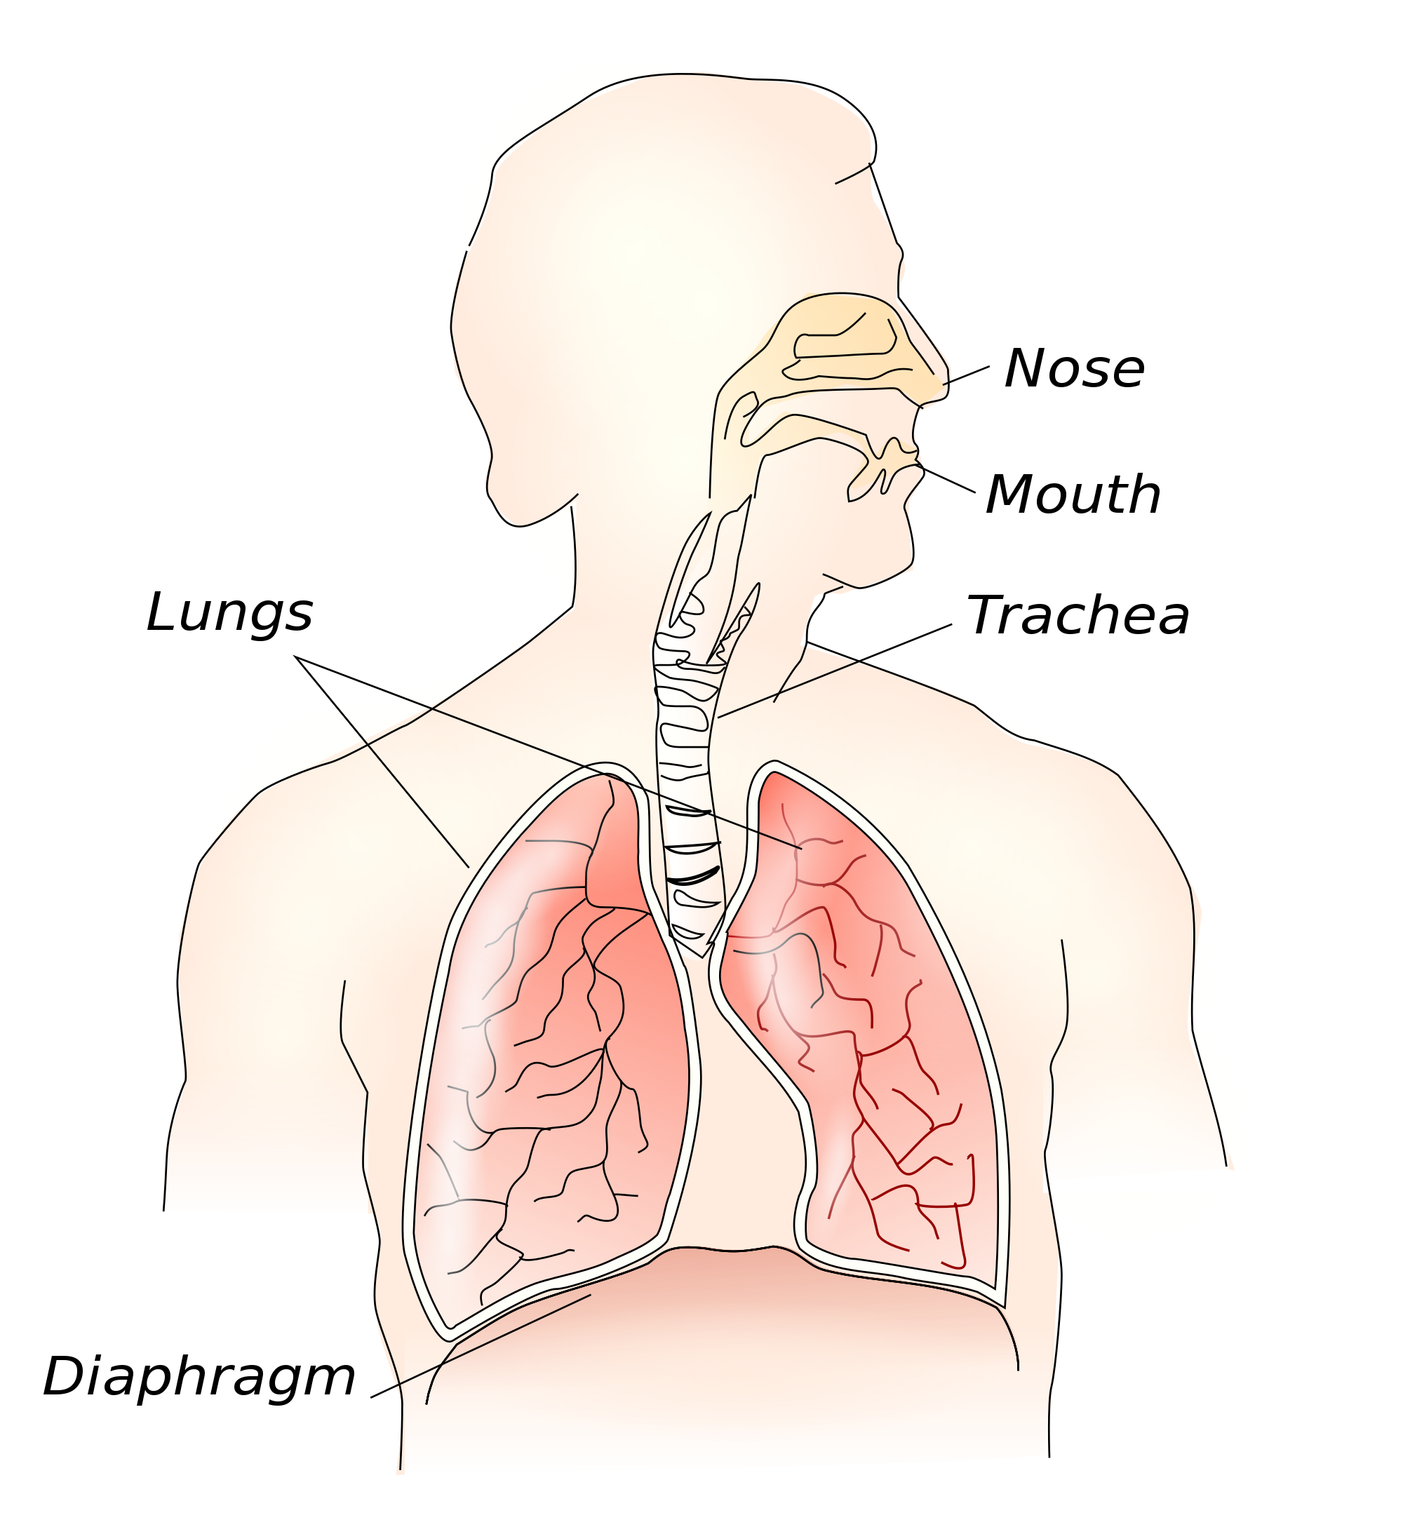
Your blood picks up oxygen from the lungs and brings it to all living cells in your body. To do this, your body depends on a pump. This pump is another important muscle called the heart. Your body cannot stay alive without oxygen. Have you ever tried to hold your breath? You probably can’t hold your breath for very long. Your body is always in need of oxygen.
Since your body needs oxygen for life, you need to know how to keep the heart healthy and the breathing muscles healthy. To do this, you need to use the muscles of the 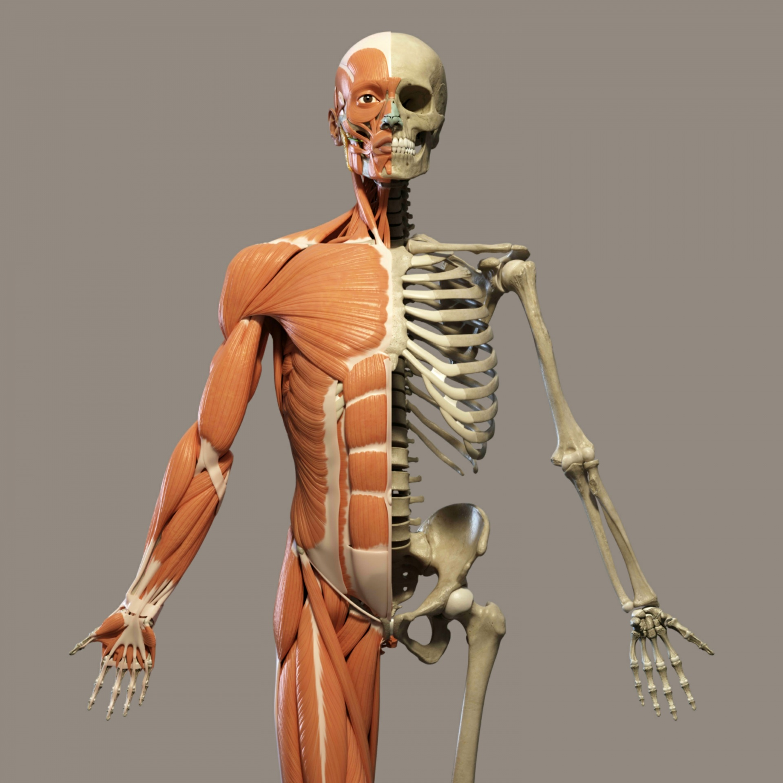body that allows you to move. The best way to keep a powerful heart pump and breathing muscles is to use your skeletal muscles. Skeletal muscles are the muscles that move your bones and allow you to move the body. It is important to be physically active so that we can keep these muscles healthy by being physically active. When you are physically active, you will likely breathe hard and exercise the breathing muscles and heart. This will make these muscles stronger and help keep them healthy. In addition to your body needing oxygen to keep you alive, your muscles need oxygen and energy from the food you eat in order to move.

In addition to using the skeletal muscles to keep the heart and breathing muscles healthy.

Part 2: Experiment

For this experiment, you will need a piece of paper, something to write with, a clock or timer, and the ability to watch this video:

http://physed.tv/view/elem-cardiorespiratory-endurance

Perhaps someone can help you with keeping the time. You will measure the changes in how fast your heart beats before, during and after physical activity.

Procedure:

- Feel your heart beating. You can do this by simply placing your hand over your heart. Sit quietly and see if you can count the number of times your heart beat for one full minute. If possible, have someone help you keep track of the time for one minute.
- Record how many times your heart beat for one minute while sitting quietly.
- Watch the video again. When the video gets to the part where it describes cardiorespiratory endurance, pause the video and feel your heart beating again and time it for one minute. Count the number of times it beat for one full minute.
- Start the video again and follow along with the activities. Again, pause the video when it discusses cardiorespiratory endurance. Record your heart beats again for one full minute. Make sure you are ready to time it for one full minute.
- Start the video again and follow along. At the end of the video, and count the heart beat for one full minute and record this number.
- Sit quietly for about 3-5 minutes. This time you will record your heart beats for one minute while sitting quietly after having participated with the video.

Results:

Now that you have recorded the number of times your heart beats for one minute before, during, and after physical activity, describe what happened in the space below.

Learning experience #2:

After learning experience #1, watch and participate in the video again. As you follow along, think about your heart, lungs, muscles, blood, and the air that you breathe while participating in the physical activity. Do you think your body uses oxygen from the air that you breathe when you are physically active?

http://physed.tv/view/elem-cardiorespiratory-endurance

After finishing the video, describe what you felt.
How did your heart, lungs, muscles, and the oxygen in the air work together?
Post your response in the “ End of Day Reflection.

