Underage Drinking Prevention National Media Campaign
Drop-In article
[ORGANIZATION NAME] to Participate in “Talk. They Hear You.”:
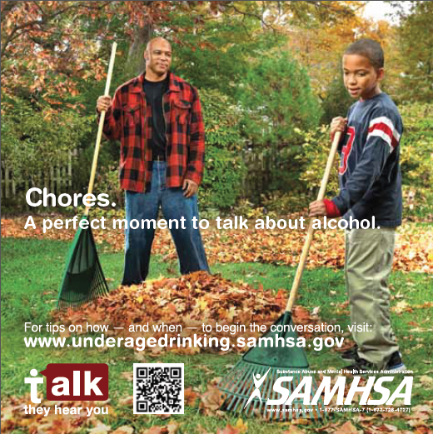
An Underage Drinking Prevention National Campaign for Parents
[INSERT DATE], [ORGANIZATION NAME] joined forces with the Substance Abuse and Mental Health Services Administration (SAMHSA) during SAMHSA’s 2013 National Prevention Week to launch “Talk. They Hear You.” “Talk. They Hear You.” is a national campaign that empowers parents to talk to their children early—as early as 9 years old—about the many risks associated with underage drinking.

[RECOMMEND ADDING PERSONALIZED QUOTE FROM ORGANIZATION REPRESENTATIVE HERE]

“These young people are our future leaders—our future teachers, mayors, doctors, parents, and entertainers,” said SAMHSA Administrator Pamela S. Hyde. “As our youth and young adults face challenges, we as a community, need to effectively communicate with them in every way possible about the risks of underage drinking so that they have the necessary tools to make healthy and informed choices.

Through “Talk. They Hear You.”, [ORGANIZATION NAME] is working with parents of children ages 9 to 15 to increase their awareness of the seriousness and pervasiveness of underage drinking and equip them with the knowledge, skills, and confidence to help prevent their children from drinking.

[ORGANIZATION NAME] will be implementing “Talk. They Hear You.” through [INSERT UPCOMING ACTIVITIES OR EVENTS].

“Talk. They Hear You.” provides [ORGANIZATION NAME] with parent resources and materials to distribute in the community, including the Campaign’s public service announcements (PSAs). These PSAs and materials show parents “seizing the moment” to talk with their kids about alcohol such as while preparing dinner or doing chores. By modeling behaviors, parents can see the many “natural” opportunities for initiating the conversation about alcohol with their children. The Campaign also offers parents a way to practice talking about underage drinking with their children through an interactive, role-play simulation they can use anytime. Check out the Talk. They Hear You. app, available now http://www.samhsa.gov/underage-drinking/mobile-application.

For more information, visit www.underagedrinking.samhsa.gov.

[INSERT ORGANIZATION WEB ADDRESS]

