PE Lessons Plans
11/29-12-17
Unit Overview/Summary
Rolling (K.1G, 1.L013, 2.1H, 3.1F, 4.L009, 5.1F)
Balance (K.1D, K.1E, 1.1C, 1.2B, 2.1E, 2.3D, 3.1D, 3.1G, 4.1E, 4.1G, 5.1D, 5.1G)

3- ninja warrior stations + backward roll /shoulder roll CURL UP TEST??? SELF ASSESSMENT
add straddle roll for students that are good at forward roll
4- PACER/ after: rolling tag
5- PUSH UP TEST??? holiday
6- holiday

FREE DAYS:
- mats for rolls/gymnastics
- peg boards
- pull up bars
- balance beams

options:
flamingo tag

Nov. 29-30
Rolling and balancing stations
Stations (cones at each station for lines). Students will rotate through all of the stations 1 time each. If there’s time at the end, they can choose a station they’d like to go back to.

balance beam (1)
- Equipment: 3 balance beams set up (3 cones)
Students will practice walking forward and sideways down the balance beam. 2nd-5th: can also practice backwards and spinning while on the balance beam.
pencil roll/log roll (2)
- equipment: 2 2-block mats set up (2 cones)
Students will practice a log roll (arms by side), pencil roll (arms by ears)
peg boards (3)
- equipment: 3 mats under the boards (3 cones)
pull up bar (4)
- equipment: 2 mats under the bars (2 cones)
side roll/egg roll (5)
- 2 2-block mats set up (2 cones)
bouncers K-1 (6)
- equipment: 3 bouncers, 3 cones. 3 rings.
Students will stand in front, pull handle between legs, and sit on the bouncer. They will bounce around the cone and back to their partner.
jump rope skills 2-5 (6)
- equipment: 8 jump ropes.
Students will practice single foot jump roping x10 each foot.
Jump rope progression:
- 10 in a row regular
- 5 in a row each foot
- 10 in a row each foot
- switching back and forth with 10 in a row each foot
cartwheel/handstand (7)
- equipment: 2 cones (1 labeled cartwheel, 1 labeled handstand).
Students will practice a cartwheel (or a side hop with hands on the ground) and handstands (or a donkey kick)
forward roll (8)
- equipment: rainbow mat, red/white mat (2 cones)
Students will practice a forward roll. If they are able to get it on their own, they can go to the other mat that I will not be at.
Forward roll:
- Squatting position with knees between arms
- Chin tucked to chest
- Hand on ground, shoulder width support
- Push off ground equally with both legs
- Roll onto shoulders
- Try to land on feet
What I say to students: HANDS, TUCK, PUSH
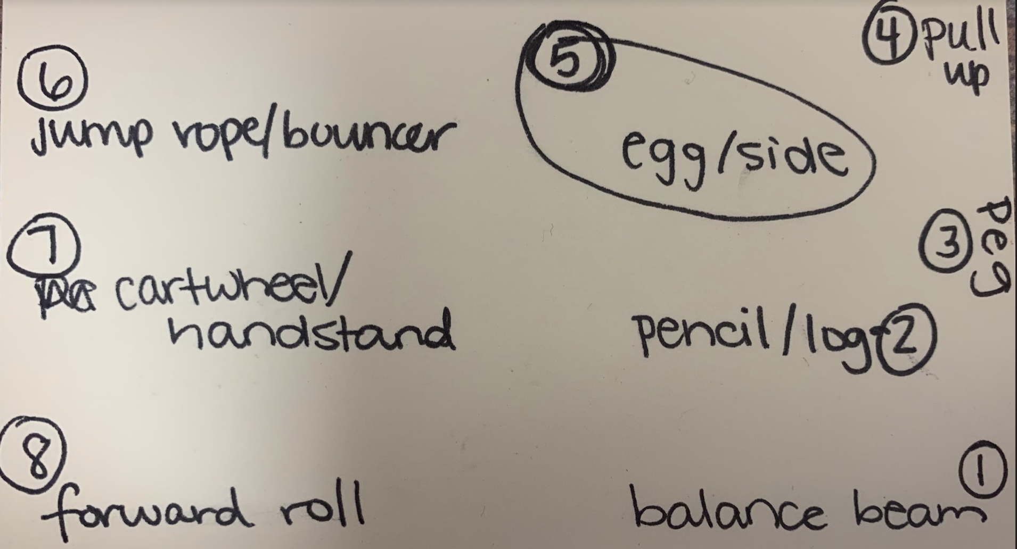
Gym set up: the bottom of the picture is the front of the gym.

Dec. 1-2 (SUB bc TAHPERD)
Rolling and balancing stations
Stations (cones at each station for lines). Students will rotate through all of the stations 1 time each. If there’s time at the end, they can choose a station they’d like to go back to.

balance beam (1)
- Equipment: 3 balance beams set up (3 cones)
Students will practice walking forward and sideways down the balance beam. 2nd-5th: can also practice backwards and spinning while on the balance beam.
pencil roll/log roll (2)
- equipment: 2 2-block mats set up (2 cones)
Students will practice a log roll (arms by side), pencil roll (arms by ears)
peg boards (3)
- equipment: 3 mats under the boards (3 cones)
pull up bar (4)
- equipment: 2 mats under the bars (2 cones)
side roll/egg roll (5)
- 2 2-block mats set up (2 cones)
bouncers K-1 (6)
- equipment: 3 bouncers, 3 cones. 3 rings.
Students will stand in front, pull handle between legs, and sit on the bouncer. They will bounce around the cone and back to their partner.
jump rope skills 2-5 (6)
- equipment: 12 jump ropes.
Students will practice single foot jump roping x10 each foot.
Jump rope progression:
- 10 in a row regular
- 5 in a row each foot
- 10 in a row each foot
- switching back and forth with 10 in a row each foot
cartwheel/handstand (7)
- equipment: 2 cones (1 labeled cartwheel, 1 labeled handstand).
Students will practice a cartwheel (or a side hop with hands on the ground) and handstands (or a donkey kick)
forward roll (8)
- equipment: rainbow mat, red/white mat (2 cones) BECAUSE I WILL BE GONE, IF THEY DON’T FEEL COMFORTABLE DOING A FORWARD ROLL BY THEMSELVES WITH NO HELP, THEY ARE TO DO A SIDE ROLL OR EGG ROLL
Forward roll:
- Squatting position with knees between arms
- Chin tucked to chest
- Hand on ground, shoulder width support
- Push off ground equally with both legs
- Roll onto shoulders
- Try to land on feet
What I say to students: HANDS, TUCK, PUSH

Dec. 3 (SUB), 10, 17
Fitness Fun Friday
K-2 FITNESS: something to do with gymnastics/balance (videos)

3-5 FITNESS: ninja warrior balance (videos?)

Free choice stations:
- peg boards
- pull up bars
- mats laid out to practice rolls (2 panel mats)
  - forward roll (2)
  - backward roll (1)
  - side/egg roll (1)
  - pencil/log roll (1)
- swinging rope
- climbing rope
- rock wall
- balance beam
- spin jammers
- jump ropes
- cartwheel/handstand practice

Dec. 6-7
K-1 rolling and balancing skill practice, R&B tag | 2-5 rolling and balancing skill self-assessment, R&B tag
Skills: (equipment per team: 3 piece mat)  - log roll  - pencil roll  - egg roll  - side roll  - forward roll  - backward roll (shoulder roll)  - cartwheel  NEW SKILL: BACKWARD ROLL  - Hug knees, tuck chin and roll back and forth  - Knees in, arms out wide (slap floor)  - One arm out, kick same foot over that arm, touch toe to mat  - Do backward shoulder roll and land on knees or feet  Rolling tag: equipment per team- 3 piece mat, 1 tagger  If you get tagged, you have to do a rolling skill or 10 single foot hops (both feet) | START WITH CURL UP TEST:  Skills: (equipment per team: 3 piecs of mat… might need to combine some)  - log roll  - pencil roll  - egg roll  - side roll  - forward roll  - backward roll (shoulder roll)  - cartwheel  NEW SKILL: BACKWARD ROLL  - Hug knees, tuck chin and roll back and forth  - Knees in, arms out wide (slap floor)  - One arm out, kick same foot over that arm, touch toe to mat  - Do full backward roll over one shoulder  Self assessment: https://docs.google.com/document/d/1CKnWJEYayIdMc2561NUaRdb3yhpBQ2w8ZUx-BWL2AJE/edit?usp=sharing  Students will assess their skills on a 0-4 scale. After practicing each skill, they will read the descriptions for the number rubric and decide where they are 0-4.  Rolling tag: equipment per team- 3 piece mat, 1 tagger  If you get tagged, you have to do a rolling skill or 10 single foot hops (both feet)

Dec. 8-9
K-1 rolling tag, NINJA WARRIOR STATIONS | 2-5 PACER
NINJA WARRIOR STATIONS:  - Roll then jumping over a river (red/blue): equipment per class: 2 jump ropes  - Roll then jumping on the tops of buildings (yellow/purple)- equipment per class: 6 hula hoops  - roll then ninja balance (orange/green)- equipment per class: 1 balance beam and 1 pool noodle  Make signs for station 1 (log and pencil), station 2 (egg and side), and station 3 (forward and backward) [x2]  Rolling Skills: (equipment per team: 3 piece mat)  - log roll  - pencil roll  - egg roll  - side roll  - forward roll  - backward roll (shoulder roll)  Rolling tag: equipment per team- 3 piece mat, 1 tagger  If you get tagged, you have to do a rolling skill or 10 single foot hops (both feet) | Dynamic warm up: Tootsie slide  - opposite toe touches  - TS then 4 knee pulls  - Frankenstein kicks  - Quad stretch  - TS then 4 knee pulls  - 10 trunk twist  - 4 long runner’s lunge  - side lunge with pause (4)  - TS then 4 knee pulls  - High knees  - butt kicks  - TS then 4 knee pulls  - Calf stretch- each  Pacer: 12 students at a time. Students on either end of the line to watch for mistakes. Holding up a 1 after first mistake. Then stopping after a second mistake. Groups of 3-4. Must have at least 3.  - Students running are 6 feet apart and can have their mask off.  - Students will report their OWN number to me. I will document them here https://docs.google.com/presentation/d/1OwL0cKexVkVG-O9IEepZ9FGEAj5Jh4s8CPyHIVjEeYo/edit?usp=sharing  If there’s time after PACER, we will talk about goals we set and play Sleepy Alligator.

Dec. 13-14
holiday

Dec. 15-16
holiday

Rolling
K.1G roll sideways (right or left) without hesitating.
- perform rolling sideways without hesitating including: right and left (pencil & log roll); backwards & forwards (rocking chair) and egg roll using various mats/wedges/tumbling aids

1.L013 demonstrate a smooth transition from one body part to the next in rolling activities, such as side roll and log rolls
- perform rolling sideways without hesitating including right and left (pencil and log roll), backwards and forwards (rocking chair) and egg roll using various mats/wedges/tumbling aids.

2.1H demonstrate smooth transition from one body part to the next in rolling activities such as side roll, log roll, balance/curl, and roll/balance in a new position.
- perform body rolling activities such as: side roll, log roll, forward/backward roll with spotters

3.1F demonstrate control and appropriate form such as curled position and protection of neck in rolling activities such as forward roll, shoulder roll, and safety rolls.
- perform rolling skills from different starting positions such as: straddle, knees and sitting

4.L009 demonstrate control and appropriate form such as curled position and protection of neck in rolling activities such as forward roll, shoulder roll, and safety rolls.
- perform rolling skills from different starting positions.

5.1F combine traveling and rolling with smooth transitions.
- practice combining locomotor movements with various rolls such as log, egg, and forward rolls

Balance
K.1D maintain balance while bearing weight on a variety of body parts.
- maintain balance while bearing weight on single & multiple body parts

K.1E walk forward and sideways the length of a beam without falling.
- walk forward and sideways: on a line on the floor (tape mark, speed rope); on a board on the floor, vary widths and lengths of board; on a beam not to exceed 4"-12" with a spotter; and on a low beam independently

1.1C demonstrate control in balancing and traveling activities.
- apply body management skills in activities such as:
    - balancing on single and multiple body parts
    - balancing for a specific amount of time
    - maintaining personal space while moving

1.2B demonstrate a base of support and explain how it affects balance.
- discuss a base of support and how to transfer body weight such as:
- shifting balance from two feet to one foot using arms out to side
- selecting a focal point
- making bridges from different body parts

2.1E demonstrate balance in symmetrical and non-symmetrical shapes from different basis of support.
- demonstrate balance in symmetrical (even base of support) and nonsymmetrical (uneven base of support) shapes from various bases of support.

2.3D lift and support his/her weight in selected activities that develop muscular strength and endurance of the arms, shoulders, abdomen, back, and legs such as hanging, hopping, and jumping.
- practice fitness test components such as push ups, curl ups, vertical jumps and pull ups

3.1D demonstrate moving in and out of a balanced position with control.
- execute and control transfer of weight while moving in and out of a balance position including: hop, jump, mount and dismount (ex. boxes, benches, steps & beams)

3.1G transfer on and off equipment with good body control such as boxes, benches, stacked mats, horizontal bar, and balance beam.
- demonstrate safe transfer on and off equipment looking for proper technique such as: proper weight transfer from upper to lower; body alignment (bending of knees & protection of back); visual judgment

4.1E perform sequences that include traveling, showing good body control combined with stationary balances on various body parts.
- demonstrate body control through various stationary balances on various body parts such as: in a rhythmic dance or gymnastics routine on floor or beam

4.1G transfer weight along and over equipment with good body control.
- demonstrate good body control as weight is transferred along and over equipment such as: balance beams and vaulting equipment and step benches

5.1D demonstrate controlled balance on a variety of objects such as balance board, stilts, scooters, and skates.
- demonstrate controlled balance in a variety of activities such as: scooters, balance boards, skate boards, and in-line skating

5.1G combine weight transfer and balance on mats and equipment.
- participate in activities that include weight transfer and balancing, such as: individual and partner stunts, tumbling, and the use of balancing equipment (balance boards, beams, boxes, etc)

