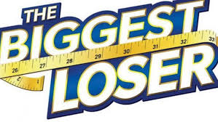
the biggest loser competition
A GMSD WEIGHT-LOSS CHALLENGE

COORDINATED SCHOOL HEALTH IS SPONSORING A 9 WEEK (01/08/2020- 03/12/2020) EACH BUILDING IN GMSD WILL BE ELIGIBLE TO PARTICIPATE AND CAN SIGN UP USING THE FOLLOWING LINK: https://forms.gle/VPaU79CtJCevWjBx8

- The official weigh-in will be on Friday, January 8th. CSH will provide a scale to each location to avoid having to drive to district office.
- You will submit your weight via a Google Form for the initial weigh-in and final weigh-in.
- The winner from each building will be determined by the overall percentage of weight lost.
- The top prize for each building’s winner will be decided by everyone that signs up, as we’ll have a survey to determine the top prizes. We want you to be motivated so we want you to pick the prize!
- We will provide resources that will help you on this journey, such as our virtual exercise and fitness pages (links provided in January Fitness Initiative Flyer).
- Need to join a gym? Look over the Healthy & Active Germantown E-Book we’ve put together to get special discounts that can help.

All participants must be registered by Thursday, January 7th and able to weigh-in on Friday, January 8th.

