Smoothie King Joins Healthy & Active Germantown
GMSD
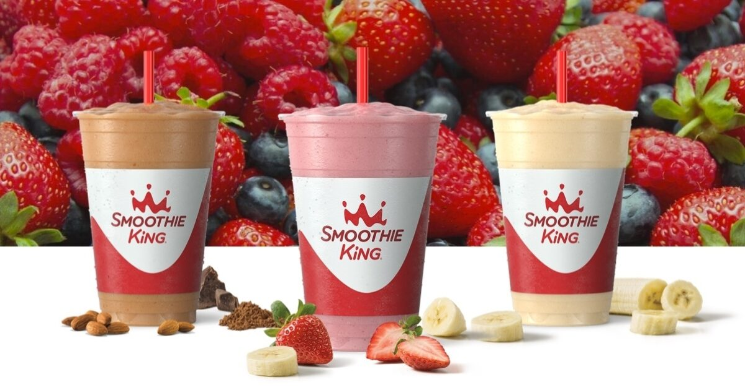

Germantown Municipal School District Employees will get a free Enhancer added to their drink when they purchase a 20 oz or larger smoothie!!

Offer valid only at the following location:

7820 Poplar Avenue, Germantown
901-309-8039

Show GMSD ID Badge at purchase

