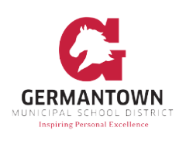
3350 S. Forest Hill Irene Rd. Germantown, TN 38138
Issued Date:
Dear Parents/Guardians,
This letter is to inform you that we have a student within the class who has life- threatening food allergies to ________________.The food allergies are severe and exposure in any form (skin contact or ingestion) to these substances could result in anaphylaxis, a potentially fatal condition that requires immediate medical attention.
For the safety of the student, we are instituting some restrictions in the classrooms. We are asking parents/guardians to be conscientious in the selection of snacks that your child brings to class to limit the chances of this child being exposed to _________________.
We know that many parents like to celebrate birthdays and other occasions with special treats. We encourage parents to celebrate with non-food items such as stickers, pencils, themed erasers, or other trinkets, rather than food. Any food sent in to share with students should be pre-packaged and contain an ingredient label. Please give these items to your child’s teacher for distribution.
Please instruct your child to not share food with other classmates.
Thank you in advance for making the class environment a safe and healthy place for the students. By working together, we can make a difference for our children. We look forward to a great school year!

Kind regards,
Coordinated School Health
901-752-7900
Andrew.martin@gmsdk12.org
