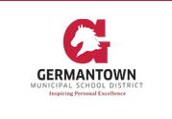
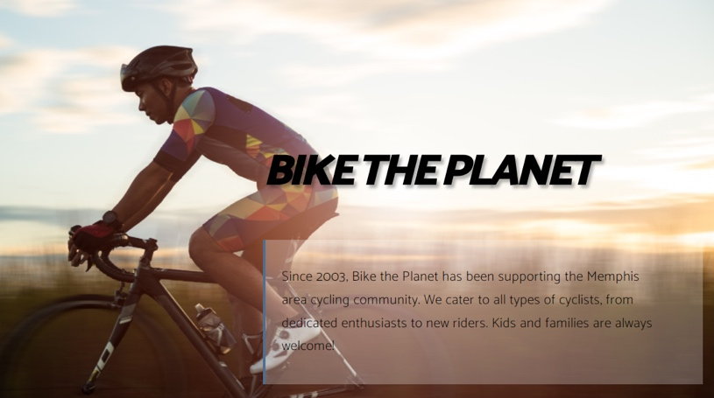
GMSD 2021-2022
Bike Safety &
Education Program
Present this flyer to the owner of Bike the Planet, Mel Clark, to receive any of the following exclusive offers. Offers are only available to GMSD students that are participating in the bike program via their Physical Education classes.

Discounts available
☐ Receive 10% off a helmet to use for the GMSD Bike Safety & Education Program.
☐ Receive 10-15% off a bike purchased from Bike the Planet.
☐ Receive a free bike inspection by bringing your bike to Mel Clark and mention that you are a GMSD student in the Bike Safety & Education Program.

Essentials for your RIDE
☐ Your bike
☐ A quality helmet
☐ Bike lights
☐ Gloves for long rides
☐ Sunscreen
☐ Eye protection/sun glasses
☐ Back pack
☐ Reflective and high visibility safety clothing
☐ Small First Aid Kit
☐ Bike repair kit: patch kit, pump (or CO2 inflator), multi-tool, spare tube

Before you Ride
☐ Do a basic bike safety check (tires, brakes, gears, chain, lights etc.)
☐ Double check you have everything on the essentials list
☐ Fill your water bottle
☐ Pack snacks to replenish your energy
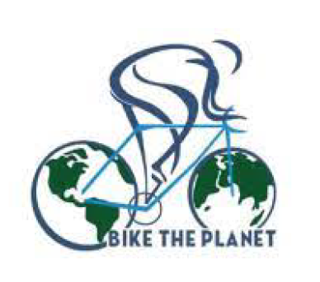
8385 US-64, Suite 104, Memphis, TN 38133
(901) 937-4669

