FUTP 60 Registration
FES 20-21
- Start by visiting www.fueluptoplay60.com

- Click the “Join Now!” button on the top right of site
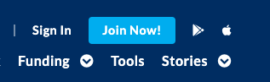

- Select your role as “student” from drop-down menu
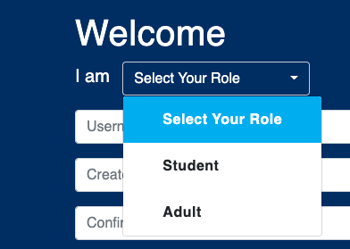

- Next, enter your birthdate
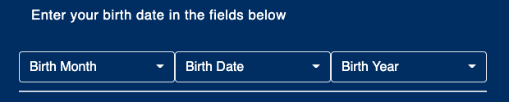

- Select a Username and Password that you will remember!! Try using a log-in that you might have with your school (easy to remember)

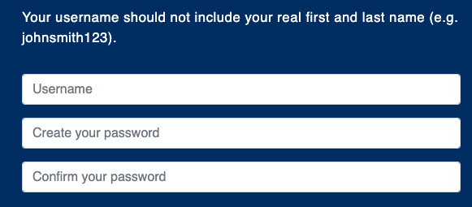

- Check the two boxes after you’ve entered your username and password. Then, click the “join” button.
- Next, you’ll be asked to select your favorite NFL team and hit the “save changes”button in order to get to your student dashboard.
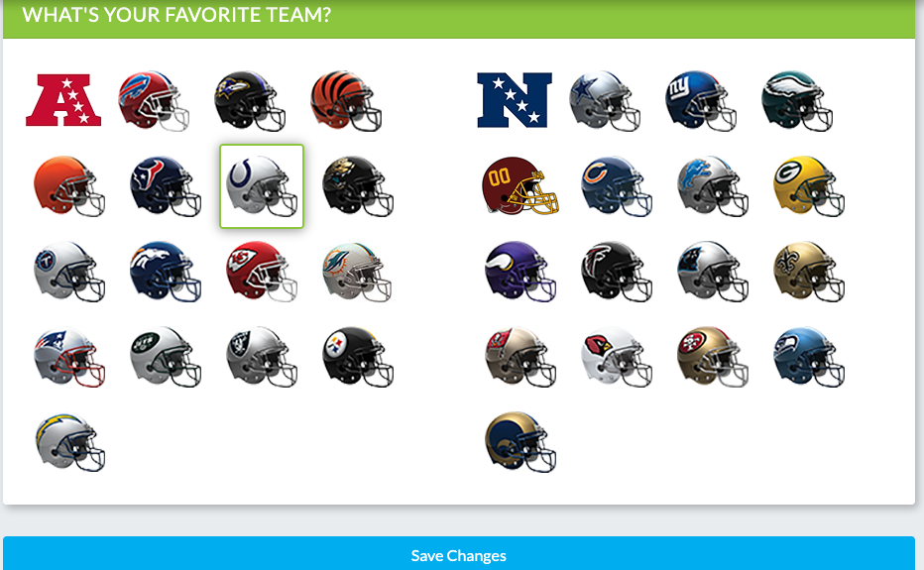

- Once on your student dashboard, you’ll see a progress board on top of the page and a welcome dashboard on left of your homepage.
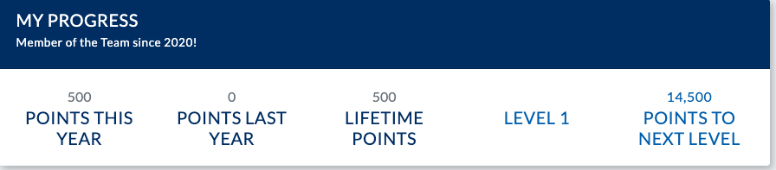

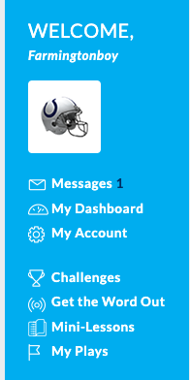

- In order to earn points, you must complete Challenges, Get the Word Out, and Mini Lessons.

10.)Once you complete a challenge, you’ll have to enter your School Team’s name to earn points: Farmington Falcons
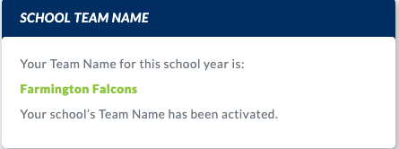

11.)After you check all the boxes for a challenge, you’ll enter the team’s name and submit. Your points will show up on your student dashboard.

*Once you reach 30,000 points, you’ll become a Student Ambassador and earn exclusive opportunities just for Student Ambassadors. You’ll have to complete the Student Ambassador nomination form (with help of your program advisors) and submit it to obtain the official title of FUTP 60 Student Ambassador. All Student Ambassadors will be eligible to apply for State Ambassador status and a chance to attend the NFL’s FUTP60 Summit during the Summer of 2021!

