Coordinated School Health Mini Grant
GMSD 2021-2022
Fall Application

In order to qualify for this grant, you must submit this application along with a narrative explaining what you’ll be using the funds for. Any equipment purchased through the CSH Mini Grant must be utilized for a lesson that can be showcased or highlighted in a CSH Newsletter.

Name of School: _____________________________________________________________

School Address: _____________________________________________________________

Teacher(s) Making request: ____________________________________________________

Project Title: ________________________________________________________________

Amount Requested: __________________________________________________________
*$500 maximum for this grant. Please do not submit a proposal for over $500, as it will not be approved.

Signature of Applicant: ________________________________________________________

Date of Application: ___________________________________________________________

CSH Mini-Grant Narrative
Fall Application

- What is the primary goal of your proposed Coordinated School Health Mini Grant Program project?

- 2. Describe your project and how having this equipment will enhance the students’ and/or teacher’s health-related learning and the anticipated numbers served. Be very clear about the activities that will occur and what results you intend to achieve.

- Describe the activity that you will do to showcase the use of the equipment to the CSH Supervisor. A description and pictures of an activity with the purchased equipment will be used to highlight in a CSH Newsletter.

Provide a project budget. Vendor must be an GSMD approved vendor. The budget will only pay for equipment. No contracted services, and salaries/benefits will be used per this grant request. Be sure to include discounts, shipping and handling in your order

*All CSH Mini-Grant Applications should be emailed to Andrew Martin once completed. The deadline for applications will be October 15, 2021. Approval of applications and ordering of equipment will take place by November 1, 2021

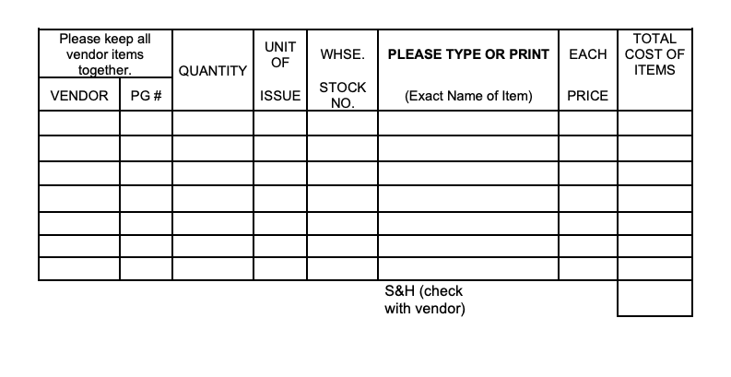
Vendor & Equipment Information

